**Section18 Making Http Requests**

**Section 18: Lecture 235//MUST READ: Angular 6 and Http**

Angular 6 is currently the latest version of Angular and it deprecates the Http-access method taught in this module.

What does this mean?

It means that the method still works, still is secure - you can use it! But there is a better Http module to use now: HttpClient.

I added a module (section 23) on that new client months ago, even before Angular 5 was released. You'll meet it later in the course and we'll easily update all our Http calls with the new client there.

So for now, follow along with this module here - the core concepts taught here will still apply (i.e. how it works etc).

And later in the course, we'll revisit this solution and update it to HttpClient.

**Section 18: Lecture 236//Introduction and how http Requests work in SPAs**

1. Here we will learn – how to make HTTP requests in an angular app. As we do need to reach out server sometimes i.e. to store something in the database.
2. Angular itself cannot access the database. So we need to reach out some server which does this for us and it gives use back the data if we need it. So, connecting to servers is important.
3. If we send request to the server, we are not getting back a new page. The request in angular is sent via Ajax.
4. 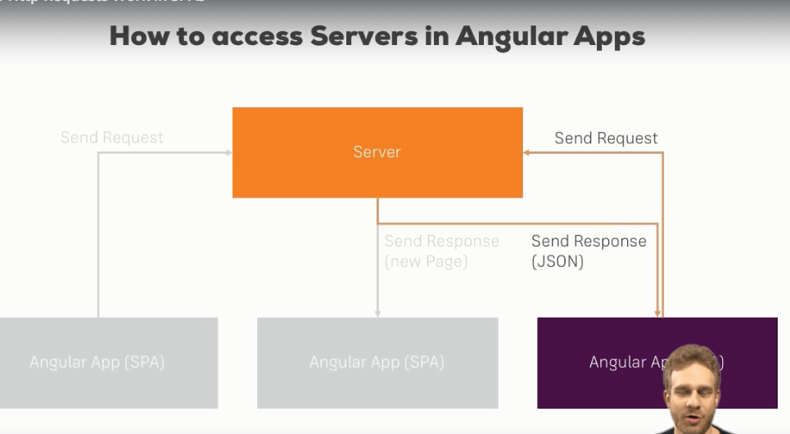

**Section 18: Lecture 237//Example App and Backend Setup**

1. In this module we will use firebase a backed by google. <https://firebase.google.com>. This will provide us a ready to use backend.
2. Here we will store the servers in the backend and fetch them from there.

**Section 18: Lecture 238//Sending Requests (Example: POST Request)**